**SDAP(SERVICE DATA ADAPTATION PROTOCOL)**

The User-plane protocol structure of NR is developed similar concepts like LTE, but obviously with some differences. The major difference in User-plane protocol structure in LTE and NR is the introduction of a new layer in the stack called SDAP.

Why new layer?

Why means difference in the QoS concept introduced in NR.

Here are some differences between LTE and NR QoS.

|  |  |
| --- | --- |
| **LTE** | **NR** |
| * LTE is connection-oriented transmission n/w, hence a logical connection between the UE and PGW is established. | * In NR, the QoS framework is based on QoS flow. It is the finest granularity in QoS differentiation. All parameters related to QoS differentiation are tied to a QoS flow. |
| * This connection is called EPS bearer, or we can say PDN connection. | * The connection called PDU session. |
| * Each EPS bearer is composed of a radio bearer (UE to eNB), S1 bearer(eNB to SGW), S5/S8 bearer(SGW to PGW). | * Each QoS flow is identified by a QoS flow ID(QFI). The QFI is unique within a PDU session. This means there can be multiple QoS flow with in a PDU session and each QoS flow will have its own QFI. |
| * Each EPS bearer has an associated QoS parameter. | * In NR, QoS framework, a Data Radio Bearer(DRB) established per QoS flow or a DRB can more than one QoS flow. |
| * There can be a more than one EPS bearer within a PDN connection. | * There is no one-one mapping for a DRB and QoS flow if SDAP configuration. |

QoS flow to DRB mapping:

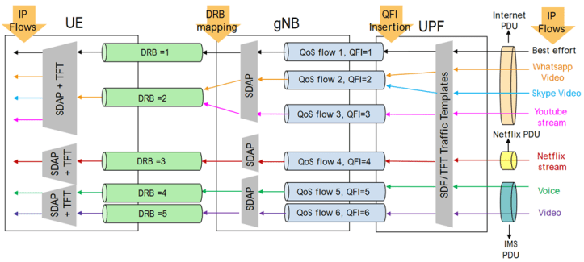

Generally, we have two types of QoS flow, GBR (Guaranteed Bit Rate) and Non GBR.

Note:

1. At Non-Access Stratum (NAS), mapping of Uplink and Downlink Packets to respective QoS flow is done by Packet Filters.
2. At AS mapping of QoS Flow to DRB is done by the rules set in UE and gNB. This is the rule that is being taken care by SDAP.

NR protocol stack:

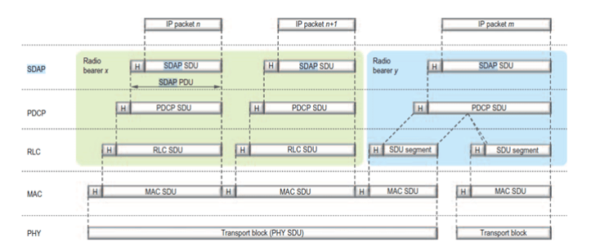

* So from the protocol stack we can see that SDAP sits on top of PDCP layer. SDAP maps the IP packets coming from application layer to specific Data Radio Bearer.
* Here we can see that IP packer n and IP packet n+1 is mapped to DRB X and IP packet m is mapped to DRB Y. The SDAP packet along with header is called SDAP PDU and the data coming from top of SDAP layer is called SDU (Service Date Unit).

SDAP PDU = SDAP SDU+HEADER

* The SDAP PDU is then forwarded to PDCP layer for further processing

**SDAP HEADER:**

RRC protocol configures the SDAP layer, and it can operate with or without a header information. The Header for SDAP is 1 Byte. Header information is included in DL in SDAP when there is a provision of reflective QoS else there is no header information added. The adding of header information can happen at the Access Stratum layer or also at the NAS layer based on the insertion of reflective QoS.

Some IMP points:

* The PDU session and QoS flow is identified by gNB by a GTP- U header.
* After this the SDAP layer maps it into specific DRB.
* If header is used for reflective QoS, SDAP layer specifies the QoS flow associated with the packet. By using this information, the UE can decode the mapping between the QoS flow and DRB for uplink transmission.
* In Downlink the QoS Flow under the PDU session is identified using identity in GTP- U Header called GTP-U tunnel End Point Identifier (TEID)

CU-DU:

CU provides support for the higher layers of the protocol stack such as SDAP, PDCP and RRC while DU provides support for the lower layers of the protocol stack such as RLC, MAC and Physical layer. Also, note that SDAP layer will not be present if the CU is connected to a [4G](https://www.5gworldpro.com/blog/2022/03/20/5g-smartphone-sales-globally-overtake-4g-sales-in-jan-2022/) Core [network](https://www.5gworldpro.com/blog/2019/04/23/57-intercontinental-shenzhen-telecom-huawei-launch-5g-smart-hotel/) as we should have 5G core network to support SDAP.

Practically speaking, there is a single CU for each gNB, but one CU controls multiple DUs, for example more than 100 DUs can be connected to one CU.

Each DU is able to support one or more cells, so one gNB can control hundreds of cells unlike the 4G BTS. Also, note that the [interface](https://www.5gworldpro.com/blog/2019/04/12/46-3gpp-5g-specifications/) between CU and DU is named F1 and as per [3GPP](https://www.5gworldpro.com/blog/2021/08/08/o-ran-3gpp-vs-o-ran-alliance/), it should be an open interface, so you connect one CU from vendor X to another DU from vendor Y.

